## Project Plan for Locus Dashboard

Target site:

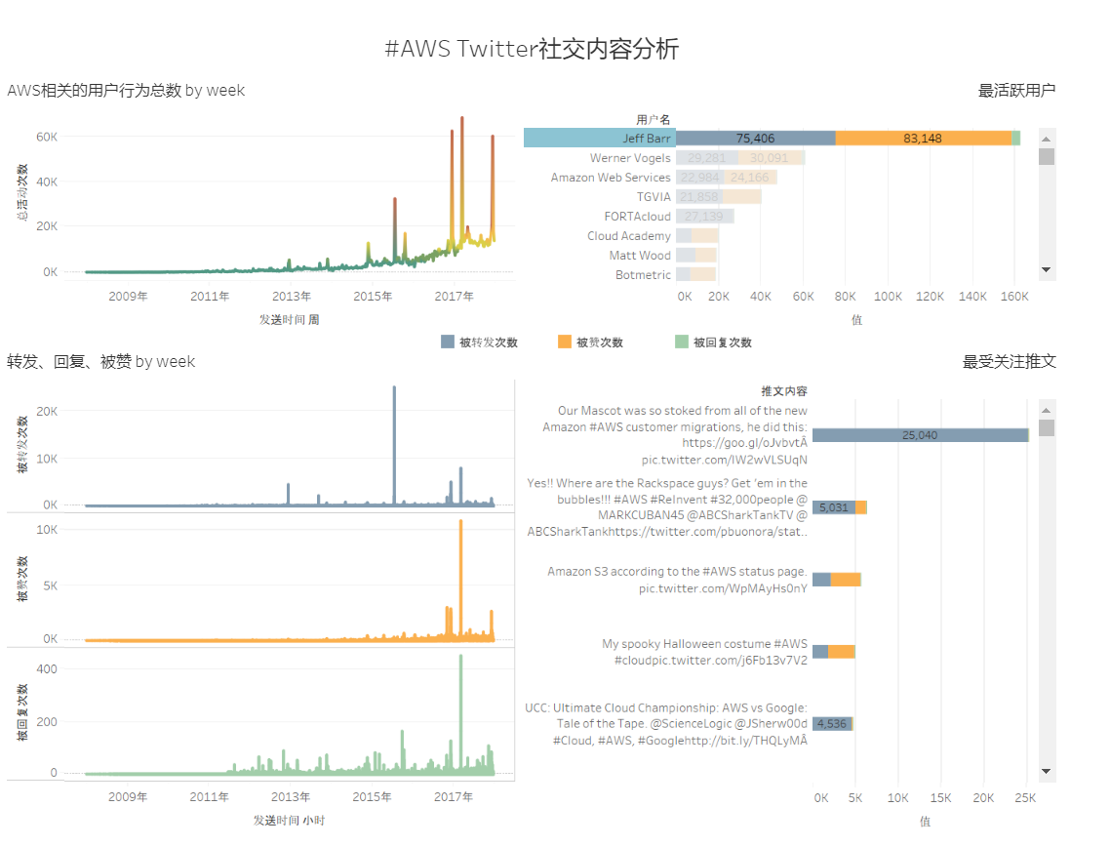

Data source: Tesla3.csv

Data fields: "时间", "Twitter ID", "用户名", "正文", "回复", "转发", "点赞"

Upload to github for ajax request "https://raw.githubusercontent.com/skywalkershen/twitter-data/master/TeslaModel3.csv"



## Features

### Graph1 features:

1. Title: 用户行为总数
2. Type: line with color gradient
3. Data needed: x: “时间”, by “年”“季”“月”“周”“时”“分”, according to “上钻/下钻查询”

Y: “总活动次数”, sum of "回复", "转发", "点赞"

1. Indicator: on mouse hover on the line
2. Tooltip: on mouse hover on the line
3. Select: on click, put a indicator on the point, add “只保留”,“排除”,“查看数据”
4. Select x-axis: high light x-axis, add “上钻 下钻 查看数据”buttons on mouse hover

### Graph2 features:

1. Title: 转发、回复、被赞
2. Type: 3 sub graph, line with color
3. Data needed: x: “时间”, by “年”“季”“月”“周”“日”“时”“分”, according to “上钻/下钻查询”

Y: "回复", "转发", "点赞" for 3 sub graphs respectively

1. Indicator: on mouse hover on the line
2. Tooltip: on mouse hover on the line
3. Select: on click, put a indicator on the point, add “只保留”,“排除”,“查看数据” buttons to Tooltip
4. Select x-axis: high light x-axis, add “上钻 下钻 查看数据”buttons on mouse hover

### Graph3 features:

1. Title: 最活跃用户
2. Type: stacked bar with 3 parts and scrollbar
3. Data needed: x: 用户名

Y: sum of activity

1. Tooltip: on mouse hover: show value of current field of the bar

5. Select stacked part:

5.1. add border for the field, darken other parts

5.2. add “只保留”,“排除”,“查看数据”to Tooltip

5.3. Select item on Y axis:

5.3.1. highlight selected item, darken other items

5.3.2. add “只保留”,“排除”,“升序排列”，“降序排列”，“查看数据”buttons to Tooltip

~~3. open new page to the twitter profile~~

5.4Select X axis: highlight x axis, add “升序排列”，“降序排列”，“查看数据”buttons to Tooltip

### Graph4 features:

1. Title: 最受欢迎推文
2. Type: stacked bar with 3 parts and scrollbar
3. Data needed: x: “正文”

Y: sum of activity

1. Tooltip: on mouse hover: show value of current field of the bar

5. Select stacked part:

5.1. add border for the field, darken other parts,

5.2. add “只保留”,“排除”,“查看数据”to Tooltip

5.3. Select item on Y axis:

5.3.1. highlight selected item, darken other items

5.3.2. add “只保留”,“排除”,“升序排列”，“降序排列”，“查看数据”buttons to Tooltip

~~3. open new page to the twit~~

5.4Select X axis: highlight x axis, add “升序排列”，“降序排列”，“查看数据”buttons to Tooltip

s

### Select Field C:\Users\SKYWAL~1\AppData\Local\Temp\1516214614(1).png

1. Select from "回复", "转发", "点赞"
2. Highlight selected field in graph 2, 3, 4, darken other parts.

### Priority

1. Layout for graph3, 4，render scrollable stacked bars with fake data
2. Layout for graph1, 3, render line with fake data
3. Data request and process
4. Sorting function
5. Tool tip features
6. Select features
7. Include exclude button

## Approach

### Choose and learn visualization library to draw the graph

D3, highgraph or echarts

Echarts and highgraph: use preset templates and layouts to build, not that flexible, but equipped with most features

D3: build everything from scratch with SVG, steep learning curve

Chose echarts

### Data fetching and processing

For graph1: get sum of activities for “时间” during the period of “年”“季”“月”“周”“日”“时”“分”

Turn[时间,Twitter ID,用户名,正文,回复,转发,点赞]

into [时间（duration），sum of activities]

For graph2: get sum of activities for “时间” during the period of “年”“季”“月”“周”“日”“时”“分”

Turn [时间,Twitter ID,用户名,正文,回复,转发,点赞]

into [时间（duration）, sum of 回复，sum of 转发, sum of 点赞]

For graph3: get sum of activities and get sum of "回复", "转发", "点赞" respectively for each “用户名”, sort the data according to the sum of activity

Turn [时间,Twitter ID,用户名,正文,回复,转发,点赞]

into [Twitter ID, 用户名(merged)， 回复，转发，点赞]

ascending and descending order

For graph4: get sum of activities for each item, sort the data according to the sum of activity

Turn[时间,Twitter ID,用户名,正文,回复,转发,点赞]

Into [时间,Twitter ID,用户名,正文,回复,转发,点赞]

Ascending and descending order

### By Steps:

##### Charts initialization (in chartxInit.js)

* 1. for chart1
* set title to change with time scale
* add dataView
* set tooltip format and content by time scale
* set x-axis-label
* encode series to match them to the desired fields
  1. for chart2
* same with chart1
* add grids to show 3 charts together
  1. for chart3:
* set brush for selecting bars
* add dataView
* set tooltip format and content
* add dataZoom as scrollbar
* set grid for showing full content of y-axis-label
* encode series to match them to the desired fields
* set ‘onbrushed’ event for getting idx of selected data items

1.4 for chart4:

Same with chart3

##### Raw data process (in data.js)

Turn input ‘Share, Reply, Like’ fields from string to number

Sort input by time

Input dedup

##### Process for each chart (in data.js)

2.1 Process for Line Charts:

* + Deep copy, turn input into ['Time', 'Reply', 'Share', 'Like', 'Total']
  + Turn ‘Time’ into milliseconds for future process
  + Add 'Reply', 'Share', 'Like' together to create ‘Total’

See TimeDrill in interactive feature for details of processing chart1,2

* + 1. Process for Chart1:

Initialize to be in scale of ‘Month’, turn input into ['Time','Total']

* + 1. Process for Chart2:

Initialize to be in scale of ‘Month’, turn input into ['Time','Total']

2.2 Process for chart3:

* Combine items from same user, turn input into ['Twitter_ID', 'UserName', 'Share', 'Like', 'Reply']
* Sort input by total

2.3 Process for chart4:

* Sort input by total
* Split lines for ‘Post_Content’ field for y-axis-label display

##### Interactive features

* 1. Drill up/ down for line charts (in timedrill.js, data.js)
* Keep time scale as global param, use it to select drill function from function array
* Add event listener on buttons to trigger time drill function and adjust time scale when clicked
* For time drill function, adjust ‘Time’ according to scale, combine items within that time duration
  1. Ascending and descending order sort according to ‘total’

Implemented with buttons bind with eventlistener and sorting function

* 1. Keep/ Remove selected data

Select implemented with brush api provided with the library(not working with line charts)

Use ‘brushed’ event to pull out idx of selected data, use button to control keeping/removing

## Result

Demo at: <https://skywalkershen.github.io/data-visualization-echarts/index.html>

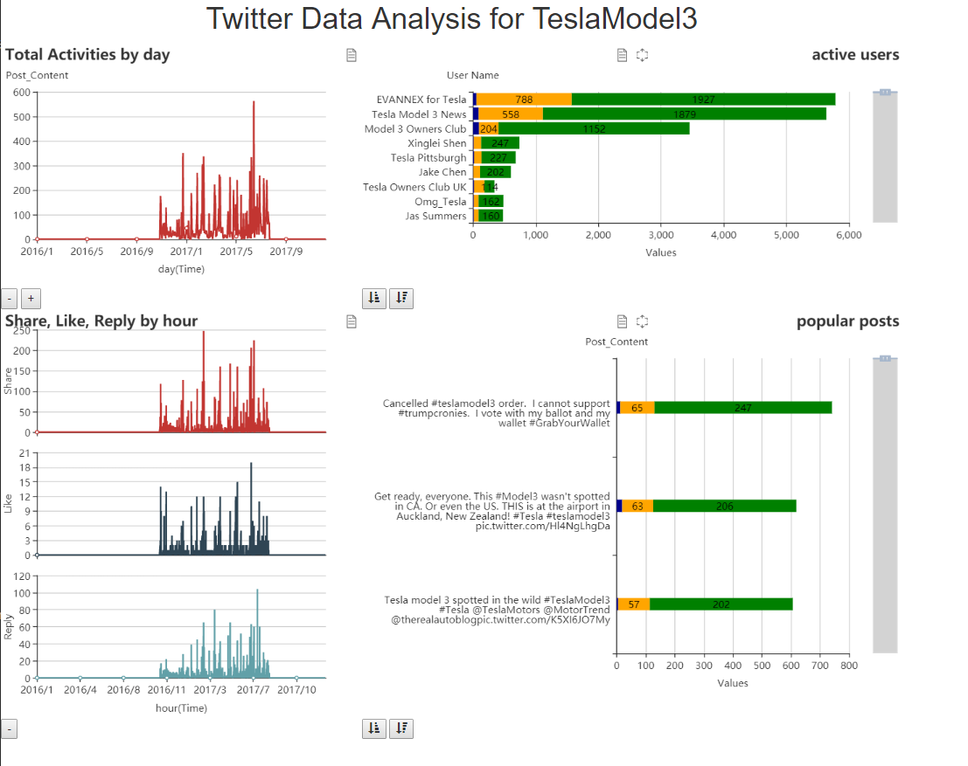

|  |  |
| --- | --- |
| objective | result |
| layout for line charts | gradient failed due to dimension bug with the library |
| Layout for stacked charts | there is no default scrollbar available for the library, set overflow of the charts to auto doesn’t work. Use datazoom component to imitate the scrollbar, yet it cannot respond to mouse scroll |
| Data request and process | Done |
| Drill up/ down | done |
| Tooltip setting | done |
| View data | Done with dataview component |
| Keep/remove selected | Only available for bar charts, and due to limit of the scrollbar implemented with datazoom, can’t scroll to select |